Making a video while playing Lotro

Option 1 | Option 2
Filming | Using screen shots (taking pictures)

Option 1: Filming

1.Using Quicktime Player

For me, this is nice and easy to use. However, I can only seem to grab the visual and not the audio but for what I use the movies for, it works out better that way. If you did want to record the audio from lotro then you might need another filming option, use audio recording software simultaneously or record on a separate device.

Filming steps | Visuals
Open Quicktime Player and go to File. | 
File ---→New Screen recording | 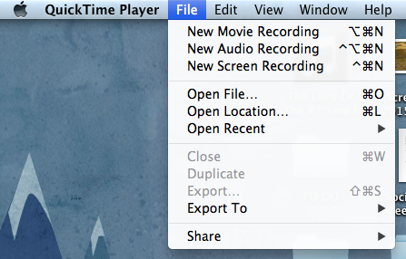
This should pop up on your screen. | 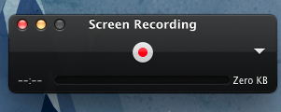
Click the red button to record.  A message should pop up.  I always click to ‘record full screen’. | Message: “Click to record the full screen. Drag to record part of the screen.”
Once you click or drag it should be recording. To know if it’s recording you should see the image to the right but instead of a red dot there should be a grey square. You should also be able to see the recording time moving.

Depending on your computer, Quicktime is able to film for as long as you have time and space.

Clear screen
Remember, if you do not want to record all of your UI onscreen information, you will need to press ctrl + U (mac users). This will temporarily remove all items from your screen while you film. To get it back click ctrl + U again. Please note that while you have it disabled you will be unlikely to see your map or fight.
When you are finished, just click on that grey square and save the video to your movies file on your computer. After you click the grey square the movie will pop up on screen and I usually click the red “x” to close it, which will then bring up a save option (see picture).  You can also choose to ‘Export to’ and send it to iMovie (if you have a mac) or iTunes (Import it to whatever movie software you are using).  Remember to give the file a name you will be able to find later. | 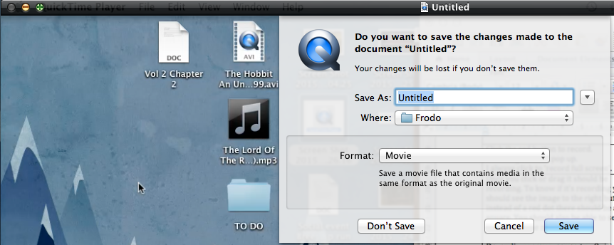

Still images (photographs/pictures)

Mac users

Cmd+shift+ 4. This will allow you to select how much of your screen you want to photograph

Cmd+shift+ 3. This will take a picture of the entire screen.

